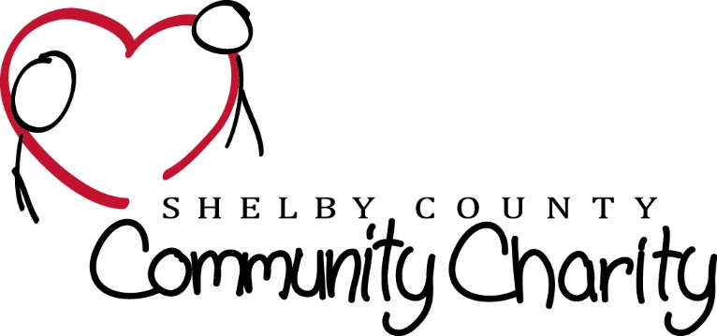

Michael Long Day Golf Scramble Entries:
Please send this form to: Shelby County Community Charity
Attn: Jimmy Willard
P.O. Box 284 Shelbyville, KY 40066-0577

NAME | PHONE | EMAIL | ADDRESS
1.)
2.)
3.)
4.)
5.)
6.)

Saturday May 9, 2015 at the Shelby County Country Club
$125 per person
Includes brunch, Golf, and on course refreshments.
Evening Activities for Golfer and one Guest

8 a.m. Brunch & Golfer Check in
9 a.m. Calcutta Auction – 10 a.m. Shotgun Start
6 p.m. Reception with food for Golfer and guest
(Must Be 21 & Older for Evening Events)
7 p.m. LIVE Auction – 8 p.m. Dance & Limited Open Bar

HOLE and CART SPONSORSHIPS

Hole Sponsor $100
(You can use your own sign or we will be happy to make you one)

Cart Sponsor $50

Cash Donation: $

Auction Donation:
Auction donation DEADLINE is Wednesday April 29, 2015
(Auction items can be picked up, dropped off at Re/max Performance Realty 30 Stonecrest Ct., Ste. 100 Shelbyville, KY 40065 or cash donation for Auction can be mailed to P.O. Box 284 Shelbyville, KY 40065. Call DANIELLE DIXON (502)523-0443 for more live auction info)

Total Amount Enclosed: $
CHECKS PAYABLE TO: Shelbyville County Community Charities or SCCC
Please ask for Your Tax deductable receipt if needed
For Additional information and questions on The Golf Tournament please Contact Jimmy Willard at (502) 321-1111
Or email: jewillard@aol.com

