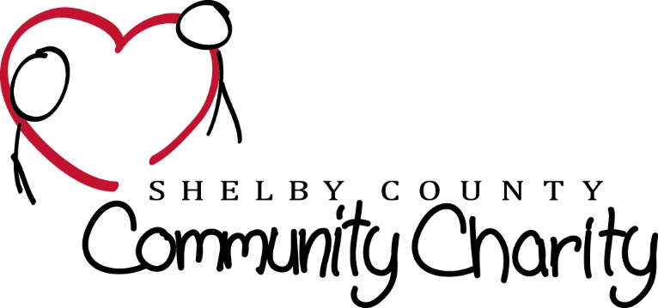

Michael Long Day Golf Scramble Entries:
Please send this form to: Shelby County Community Charity
P.O. Box 284 Shelbyville, KY 40066 or email to jimmy@hbarrysmith.com
NAME | PHONE | EMAIL | ADDRESS
1.)
2.)
3.)
4.)
5.)
6.)

Friday & Saturday May 10 and 11, 2024 at the Shelby County Country Club
CELEBRATING 29 YEARS!!
Friday Evening, May 10th
Celebration kickoff with lite Food/ cash bar/Small Live Auction/ Raffle /Music/At the Clubhoudr
Tee Times available Friday May 10th for Practice Rounds
(Sign up and Pay at Pro Shop)

Saturday May10th- *Golf Scramble* $125 per person
Includes Brunch, Golf, and 6 tickets for on Course Refreshments.
Lunch is provided with cash donation
9 a.m. Brunch & Golfer Check in
10 a.m. Calcutta Auction – 10:30 a.m. Shotgun Start
4 p.m.(ish) Scramble Winners Announced /Closing Ceremony with LIVE Auction.
Music Entertainment / Cash Bar to follow down at the Members Lounge
(Must Be 21 & Older for Evening Events)
Saturday evening event is open to non-Golfers/The Public

HOLE SPONSORSHIPS, CASH and AUCTION DONATIONS: SEE REVERSE SIDE!

Hole Sponsor $100
(You can use your own sign or we will be happy to make you one)

Cash Donation: $

Auction Donation:
Auction donation DEADLINE is Wednesday Msy8, 2024
Auction items can be picked up or dropped off at HOME|LAND of KY., 179 Alpine Drive, Shelbyville, KY. 40065 or cash donation for Auction can be mailed to P.O. Box 284 Shelbyville, KY 40066. Call DANIELLE DIXON (502)523 -0443 for more live auction information.

Total Amount Enclosed: $
CHECKS PAYABLE TO: Shelbyville County Community Charities or SCCC
Please ask for Your Tax deductible receipt if needed
For Additional information and questions on The Golf Tournament please Contact Jimmy Willard at (502) 321-1111
Or email: jimmy@hbarrysmith.com

CORPORATE SPONSORSHIP OPPORTUNITIES
SHELBY COUNTY COMMUNITY CHARITY
29TH ANNIVERSARY OF THE MICHAEL TODD LONG GOLF TOURNAMENT

PLATINUM LEVEL - $5,000: Includes two team entries for 6 players each, a banner along entrance and major highway, organization or business name/logo on golf balls given to all players and Long Drive Contest sponsor.

GOLD LEVEL - $2,500: Includes one team entry for 6 players, two hole sponsor signs, banner displayed at Clubhouse, and Hole in One contest sponsor. Closest to Pin contest sponsor.

SILVER LEVEL - $1,500: Includes one team entry for 6 players and a banner displayed at the clubhouse and sponsorship of all rental carts during the golf tournament.

BRONZE LEVEL - $1,000: Includes one team entry for 6 players and a banner displayed at the clubhouse.

BRASS LEVEL: - $500: Includes banner displayed at club house and one hole sponsorship.

ADDITIONAL DONATIONS: Any amount is acceptable as a donation that will be used for prize money, cart rentals, promotional materials, and other tournament related expenses.

